**National Strategic Plan**



**Persekutuan Pengakap Malaysia**

**Towards 2025**

(2014-2017)



**Misi Persekutuan Pengakap Malaysia**

**The Mission of the Scout Association of Malaysia**

Misi Kepengakapan ialah memberi sumbangan kepada pendidikan generasi muda, melalui satu sistem nilai yang berasaskan kepada Persetiaan dan Undang-undang Pengakap, membantu membina dunia yang lebih baik, di mana penduduknya boleh berdikari sebagai individu serta dapat memainkan peranan yang berguna untuk masyarakat.

*The mission of Scouting is to contribute to the education of young people, through a value system based on the Scout Promise and Law to help build a better world where people are self-fulfilled as individuals and play a constructive role in society.*

INI AKAN DAPAT DICAPAI MELALUI :

***THIS IS ACHIEVED BY****:*

* Penglibatan berterusan dalam proses pendidikan non formal
* *involving them throughout their formative years in a non-formal educational process*
* Menggunakan kaedah khusus untuk menjadikan setiap individu sebagai agen utama pembangunan diri supaya dapat berdikari, bertanggungjawab dan komited
* *using a specific method that makes each individual the principal agent in his or her development as a self-reliant, supportive, responsible and committed person*
* membantu mereka membina sistem nilai berasaskan prinsip-prinsip kerohanian, sosial dan keperibadian seperti yang ternyata dalam Persetiaan dan Undang-undang Pengakap
* *assisting them to establish a value system based upon spiritual, social and personal principles as expressed in the Promise and Law.*



**Visi Persekutuan Pengakap Malaysia (PPM)**

**We see PPM by 2025**

**Menjelang 2025 PPM akan dilihat sebagai**

**An efficiently managed, modern, self-dependent, organization providing value based quality youth program through responsible and capable leaders towards developing useful citizens**

**Sebuah organisasi yang diurus secara cekap, moden dan berdikari bagi menyediakan program muda remaja yang berkualiti, berteraskan nilai melalui pemimpin yang bertanggungjawab dan berwibawa membangun warganegara yang berguna.**

**SWOT Analysis**

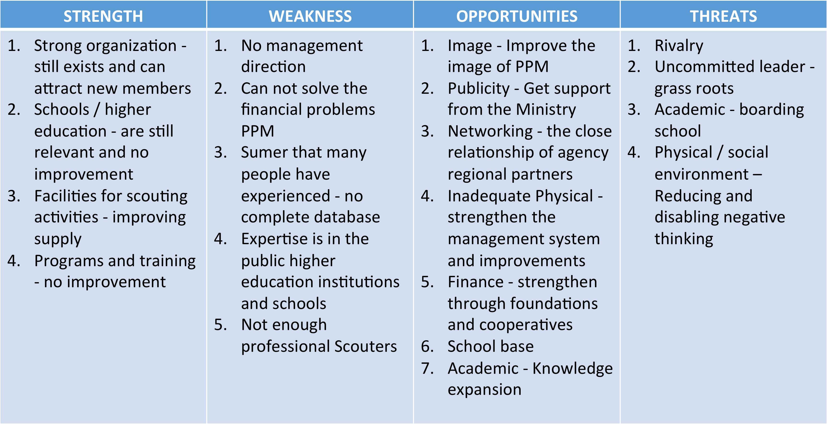

**STRATEGIC PRIORITIES**

1. **ORGANIZATION**

To review the organizational structure, systems and management at all levels so as to become an organization that is lean, flexible and innovative.

1. **YOUTH INVOLVEMENT**

To involve young people in decision making process for their own development so that they can be empowered to play a constructive role in society.

1. **ADULTS IN SCOUTING**

To develop strategies and concept on volunteering so as to broaden the base for the recruitment and retention of Adults in Scouting.

1. **SCOUTING PROFILE**

To enhance the communication system, establish win-win partnership and increase the financial opportunities to better achieve the Mission of Scouting.

**OBJECTIVES AND ACTION PLAN**

|  |  |
| --- | --- |
| **Strategic Priority: *ORGANIZATION***  To review the organizational structure, systems and management at all levels so as to become an organization that is lean, flexible and innovative. | |
| **Objective 1:**  To review the Constitution of PPM by December 2016 | |
| **ACTION STEPS** | **WHO (Key Persons)** |
| **Action Step 1**  Complete final draft by June 2015 | Chief Commissioner |
| **Action Step 2**  Submission to Scout Council by September 2015 | Chief Commissioner |
| **Action Step 3**  Adoption of constitution by EGM January 2016 | Chief Commissioner |
| **Action Step 4**  Adoption by AGM by January 2016 | Chief Commissioner |
| **Action Step 5**  To send constitution to APR/WOSM by June 2016 | Chief Commissioner |
| **Objective 2:**  To achieve the Global Support Assessment Tools (GSAT) certification by December 2018 | |
| **Action Step 1**  To obtain the document from APR Office by March 2015 | Chief Operations Officer |
| **Action Step 2**  Study, analyze and execute at National level by December 2016 | Chief Commissioner |
| **Action Step 3**  Get certification for GSAT by December 2018 |  |

|  |  |
| --- | --- |
| **Strategic Priority: *YOUTH INVOLVEMENT***  To involve young people in decision making process for their own development so that they can be empowered to play a constructive role in society | |
| **Objective 1:**  To propose a new youth programme for PPM so as to be in line with the World Scout Youth Programme Policy by December 2016 | |
| **ACTION STEPS** | **WHO (Key Persons)** |
| **Action Step 1**  Form a Task Force, including young people at National Level by March 2015 | National Programme Commissioner (NPC) |
| **Action Step 2**  Organize one National Youth Forum by August 2015 | NPC with young people |
| **Action Step 3**  Report of the new Youth Programme, the reports of the youth forums and submit the recommendations to the National Programme Committee by March 2016 | National Programme Commissioner (NPC) |
| **Action Step 4**  Adoption of the new Youth Programme by NPC by June 2016 | National Programme Commissioner (NPC) |
|  |  |
| **Objective 2:**  To review the Policy on Youth Involvement and empowerment in decision making by December 2016 | |
| **Action Step 1**  Form a Task Force, including young people at National Level by March 2015 | National Programme Commissioner |
| **Action Step 2**  To create PPM Youth Policy to be in line with the National Policy, APR/WOSM by March 2016 | National Programme Commissioner |
| **Action Step 3**  Adopt the revised PPM Youth Policy by NEC by December 2016 | National Programme Commissioner |
| **Objective 3:**  To implement the New World Scout Youth Programme by December 2017 | |
| **Action Step 1**  Prepare relevant literature and dissemination at all levels by March 2016 | NPC / Public Relations Commissioner (PRC) |
| **Action Step 2**  Launching of the new youth programme by June 2016 | National Programme Commissioner |
| **Action Step 3**  Organize seminars at National, State and District levels for all leaders at all levels for the purpose of presenting the new Youth Programme by December 2016 | National Programme Commissioner |

|  |  |
| --- | --- |
| **Strategic Priority: *ADULTS IN SCOUTING***  To develop strategies and concept on volunteering so as to broaden the base for the recruitment and retention of Adults in Scouting | |
| **Objective 1:**  To continuously promote Adults in Scouting concept at all levels | |
| **ACTION STEPS** | **WHO (Key Persons)** |
| **Action Step 1**  Include training module on Adults in Scouting in all adult training courses | National Training Commissioner (NTC) /National Adult Resources Commissioner (NARC) |
| **Action Step 2**  Organize seminars, conferences and meetings at all levels including lay members on recruitment and retention as per AIS concept beginning June 2015 | National Training Commissioner (NTC) /National Adult Resources Commissioner (NARC |
| **Action Step 3**  Acquire and disseminate relevant literature on AIS | National Training Commissioner (NTC) /National Adult Resources Commissioner (NARC |
| **Objective 2:**  To implement the World Adult in Scouting Policy (WASP) at all levels by December 2017 | |
| **Action Step 1**  Adoption by NTC by March 2015 | National Training Commissioner |
| **Action Step 2**  Adoption and Implementation at National level by June 2015 | National Training Commissioner |
| **Objective 3:**  To review and implement the training scheme by December 2017 | |

|  |  |
| --- | --- |
| **Action Step 1**  Review present scheme and make recommendations by June 2015 | National Training Commissioner |
| **Action Step 2**  Adoption of the plan to the National Training team by December 2015 | National Training Commissioner |
| **Action Step 3**  To organize at least one CALT / CLT in a year/annually | National Training Commissioner |
| **Action Step 4**  To translate relevant and latest training materials and disseminate them promptly | National Training Commissioner |

|  |  |
| --- | --- |
| **Strategic Priority**: ***SCOUTING PROFILE***  To enhance the communication system, establish win-win partnership and increase the financial opportunities to better achieve the mission of Scouting | |
| **Objective 1:**  To review the organizations’ communication system by December 2015 | |
| **ACTION STEPS** | **WHO (Key Persons)** |
| **Action Step 1**  Analyze the existing system with the aim of improving the internal and external flow of information and submit reports and recommendations by March 2015 | Profile Commissioner |
| **Action Step 2**  Appointment of a full-time Webmaster to manage PPM’s website on a monthly basis by June 2015 | Chief Commissioner |
| **Action Step 3**  Implementation of **Action Step 1** by August 2015 | ICT Commissioner |
| **Action Step 4**  Appointment of state level webmaster by August 2015 | State Chief Commissioner |
| **Objective 2:**  To continuously strengthen PR practices ensuring media coverage on Scouting Events | |
| **Action Step 1**  Conduct a national PR seminar/workshop by June 2015 | National PR Commissioner |
| **Action Step 2**  Ensure issuance of Press releases before, during and after each National Scouting Event at all level | National PR Commissioner |
| **Action Step 3**  Conduct media gathering annually between PPM and the Members of the Media | Chief Commissioner/ National PR Commissioner |
| **Objective 3:**  To identify at least one project annually to support the growth of Scouting and establish partnership with other agencies for financial and technical support. | |
| **Action Step 1**  To Identify and write project proposals | Chief Commissioner  /PR/Foundation |
| **Action Step 2**  To Establish Partnership with other agencies | Chief Commissioner  /PR/Foundation |
| **Action Step 3**  To implement and the report of the project | Chief Commissioner  /PR/Foundation |

**SUPPORT STRUCTURE**

**STRATEGIC PLANING IMPLEMENTATION COMMITTEE**

CHIEF SCOUT

(KPN)

ADVISOR

CHIEF

COMMISSIONNER

(KPPN)

ASST. CHIEF

COMMISSIONNER

(TKPPN)

CHIEF EXCECUTIVE

OFFICER

(CEO)

SECRETARY

VICE CHAIRMAN

CHAIRMAN

5 SELECTED MEMBER

STATE CHIEF COMMISSIONNER

ORGANISATION

YOUTH INVOLMENT

ADULT IN SCOUTING

SCOUTING PROFILE

CHAIRMAN

CHAIRMAN

**EVALUATION CRITERIA:**

**PERSEKUTUAN PENGAKAP MALAYSIA (PPM)**

**2015-2025**

|  |  |  |  |
| --- | --- | --- | --- |
| **WHEN to evaluate** | **WHAT to evaluate?** | **HOW to evaluate?** | **WHO will evaluate?** |
| Every 3 months | Pre-Present-Post   * Program Progress * Training Progress * Financial Report | Pre-post   * Proposal paper * Gantt Chart * Distribution of allocation | Implementation Committees |

|  |  |  |  |
| --- | --- | --- | --- |
| Every 18 Months | Progress Report  (Achievement and Challenges)   * Actions Vs. Achievement * Objectives Vs. Achievement * Vision Vs. Achievement | * Workshop | National Executives/Council Members  Implementation Committees members  State Representatives |

|  |  |  |  |
| --- | --- | --- | --- |
| Every 6 months | Progress Report  (Achievement and Challenges)   * Quantity * Quality * Action Taken | * Survey * Report | National Council/Executive Committee  Sub Committees  Implementation Committee |



**RECOMMENDATION**

**Persekutuan Pengakap Malaysia**

**National Strategic Planning Workshop**

We, the participants of the National Strategic Planning Workshop held in Kuala Lumpur, Malaysia, from 17th to 21st November 2014, strongly recommend to Persekutuan Pengakap Malaysia as follows :

1. To form Strategic Planning Implementation Committee (SPIC) that will evaluate the process of implementation, monitoring and publicity of the National Strategic Planning for year 2015 -2025.
2. To accept and adopt the National Strategic Planning as presented for better performance of the Persekutuan Pengakap Malaysia.
3. To print and promptly disseminate nationwide the National Strategic Planning Persekutuan Pengakap Malaysia towards year 2015 -2025. Also ensure to upload on PPM website.
4. To make necessary budgetary provisions to meet the expenses for the implementation of the plan.
5. To organise all future programme/events in line with the National Strategic Plan.
6. To adopt a check and balance approach in all committees framed in the proposed Strategic Planning Implementation Committee (SPIC) to allow accountability and transparency.
7. To continuously monitor and evaluate the progress of plan implementation, and every 18 months organise a review workshop with all members of the respective implementation committees and state representatives.
8. To involve all stakeholders in the implementation of the strategy at all levels of Persekutuan Pengakap Malaysia.

**Recommendation Committee:**

1. Mohammad Zaki bin Mohd Yusof
2. Mohd.Zulkifli bin Dato’ Haji Maulud
3. Siti Khadzimah binti Sallip
4. Abd Rahim bin Mohamad
5. Amir Hamzah bin Aman

**This plan is adopted with recommendations that the Task Group, without changing the contents shall review considering the following points before its final printing:**

**Language**

**Lay-out/page set**

**Use full form of terminologies and not abbreviations**



**National Strategic Planning Workshop**

Persekutuan Pengakap Malaysia

International Youth Centre, Kuala Lumpur Malaysia  
17-21 November 2014